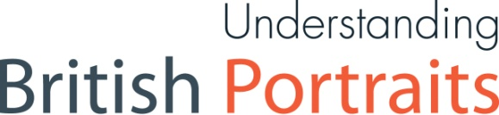

APPLICATION FORM
Fellowships for early career collection professionals in the UK: Decolonising portrait interpretation

Your details
Name
Job title
Organisation name and address
Accreditation number (if applicable - let us know if you are working towards Accreditation)
Email address
Phone number
Title of your proposed Fellowship (approx. 20—30 words)

Your proposed project (max. 500 words)
Please describe your Fellowship project; why you have chosen it, and the proposed methodology.

Your proposed output(s) (max. 500 words)
Please describe the planned output(s), including expected beneficiaries.

Your proposed use of project budget
The total Fellowship budget is £4,000, up to £1,800 of which can be used for salary back-fill (see Fellowship description). The balance of £2,200 is project budget, and is intended for (1) research travel, overnight accommodation, and/or subsistence and (2) at least one tangible and sustainable output with long-term impact. Describe here your expected use of budget, citing evidence for your estimates where available.
Funds should not be earmarked for training courses, conference fees, freelance fees, or conservation work. Please get in touch with us in advance with any queries.

Statement of support (max. 500 words)
Your line manager or other senior member of your organisation should add a statement supporting your application which recognises the value and feasibility of the proposed project. This should;
- reference your organisation’s statement/declared commitment to anti-racism, and how the Fellowship project will contribute towards that work.
- outline how the Fellow, if successful, will be supported and championed in-house.
- describe your organisation’s commitment to learn from the Fellowship, and embed these lessons more widely within your collection practice.
- confirm agreement to administer suitable back-fill arrangements

Name
Job title
Relationship to applicant (line manager, etc.)
Organisation name and address
(if different from applicant)
Email address
Phone number

Please email this form in Word format only to cpegum@npg.org.uk by 12 noon, Friday 18 December 2020.

